Contents
Phase 1: Business Definition, Questions & KPIs 3
1. Business Overview 3
2. Business Questions 3
3. Key Performance Indicators 4
Phase 2 & 3: Database Design (8 Normalized Tables - 3NF) 5
Key Constraints Needed 6
Phase 4 & 5: Implementation Roadmap 6
Local Development (PostgreSQL or SQL Server) 6
Local_Queries_Success.png 7
Query:1 8
Query:2 8
AWS RDS Deployment 8
9
Phase 6: Cloud Data Pipeline (S3 + Glue + Athena) 10
Created IAM Role: PulseChargeGlueRole 11
Step 1: Create a Glue Database 11
Database Catalog 11
Step 2: Choose data sources and classifiers 11
Step 3: Configure security settings 12
Step 4: Set output and scheduling 13
Amazon Athena 16
Data Transformation & Pipeline Automation (Glue ETL). 17
Step-by-Step Setup: CSV to Parquet Pipeline 17
Phase 7: Data Mining & Analytics 20
Queries on Athena 20
Query 1: Overall Network Performance (Aggregation) 20
Query 2: High-Volume Customer Segmentation (Thresholding Analysis) 21
Query 3: Session Energy Categorization (Classification Logic)SQL 22
Query 4: Customer Usage Tier Ranking 24
Phase 8: Dashboard & Final Submission Checklist 27
Conclusion: 27
PulseCharge Data Lake & Analytics Pipeline 27

Phase 1: Business Definition, Questions & KPIs

Business Overview
- Company: PulseCharge Network North America
- Business Model: PulseCharge operates fast-charging EV stations. Revenues are generated via energy delivery fees (kWh), session usage tariffs, and monthly subscriptions.
- Core Problem: Dynamic demand leads to station bottlenecks during peak hours, under-utilized chargers in suburban areas, unexpected downtime, and customer churn. PulseCharge needs a centralized database and data pipeline to optimize station availability, dynamic tariffs, and proactive maintenance.

2. Business Questions
1.Which charging stations generate the highest revenue per month?
2.What is the overall station occupancy rate during morning/evening peak hours versus off-peak hours?
3.Which charger types (Level 2 vs. DC Fast Chargers) experience the highest downtime rate?
4.What is the average session duration and energy delivered (kWh) per EV model type?
5.How does dynamic pricing (tariffs) impact customer session length and total revenue?
6.Which customer segments exhibit the highest churn or lowest retention rate over 90 days?
7.What are the most frequent root causes listed in unresolved maintenance tickets?
8.Which geographic clusters of stations represent high-demand vs. low-utilization corridors?

3. Key Performance Indicators

Average Session Revenue ($/session): (Total Revenue)/ (Total Charging Sessions)
- Station Occupancy Rate (%): (Total Charging Hours) /(Total Available Charger Hours)X 100
- Peak Energy Delivered (kWh): Sum of energy dispensed during peak window (07:00–10:00 & 16:00–19:00).
- Charger Downtime Rate (%): (Total Outage Hours / Total Operating Hours) X100
- 90-Day Customer Retention Rate (%): (Active Repeat Customers in 90 days / Total Customers) X 100

Phase 2 & 3: Database Design (8 Normalized Tables - 3NF)
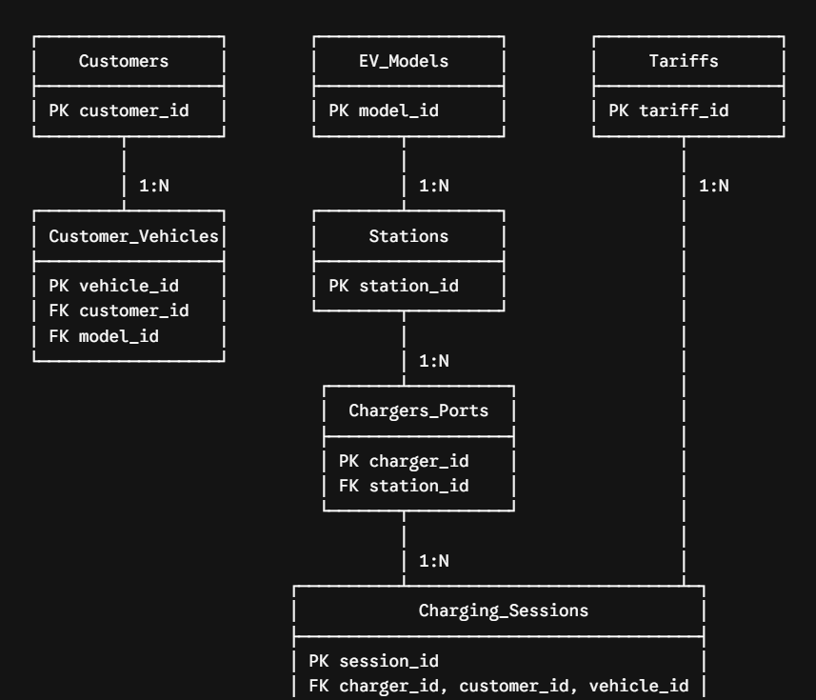

Key Constraints Needed
- NOT NULL on session start times, customer emails, rates.
- UNIQUE constraint on customer.email and chargers_ports.serial_number
- CHECK constraints: energy_kwh >= 0, port_status IN ('Available', 'Occupied', 'Offline', 'Maintenance'), downtime hours >= 0
- We have prepared Python Data Generator Script (generate_ev_data.py).

Phase 4 & 5: Implementation Roadmap

Local Development (PostgreSQL or SQL Server)
- Generate synthetic dataset (1,000+ rows across all tables) using Python
- Write Local_Database.sql to build local schema, tables, foreign keys, and constraints.
- Import data into local database using CSV Import Wizard or Python pandas
- Create required database objects:
- 3 Views: e.g., vw_station_daily_performance, vw_active_maintenance_issues, vw_customer_usage_summary
- 3 Stored Procedures/Functions: e.g., sp_calculate_session_cost(), sp_flag_offline_chargers(), sp_customer_churn_risk()
- 12 Analytical Queries: CTES, Window functions (AVG() OVER(), RANK()), Aggregates, Multi-table Joins.
We have SQL schema script (Local_Database.sql) formatted for PostgreSQL. It builds all 8 normalized tables in 3NF with strict data integrity constraints, primary keys, and foreign key relationships.
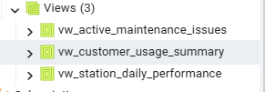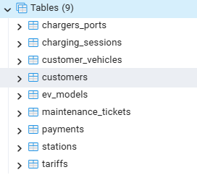

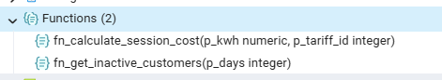

- The Local_Database.sql script open in VS Code or pgAdmin containing the 12 query statements

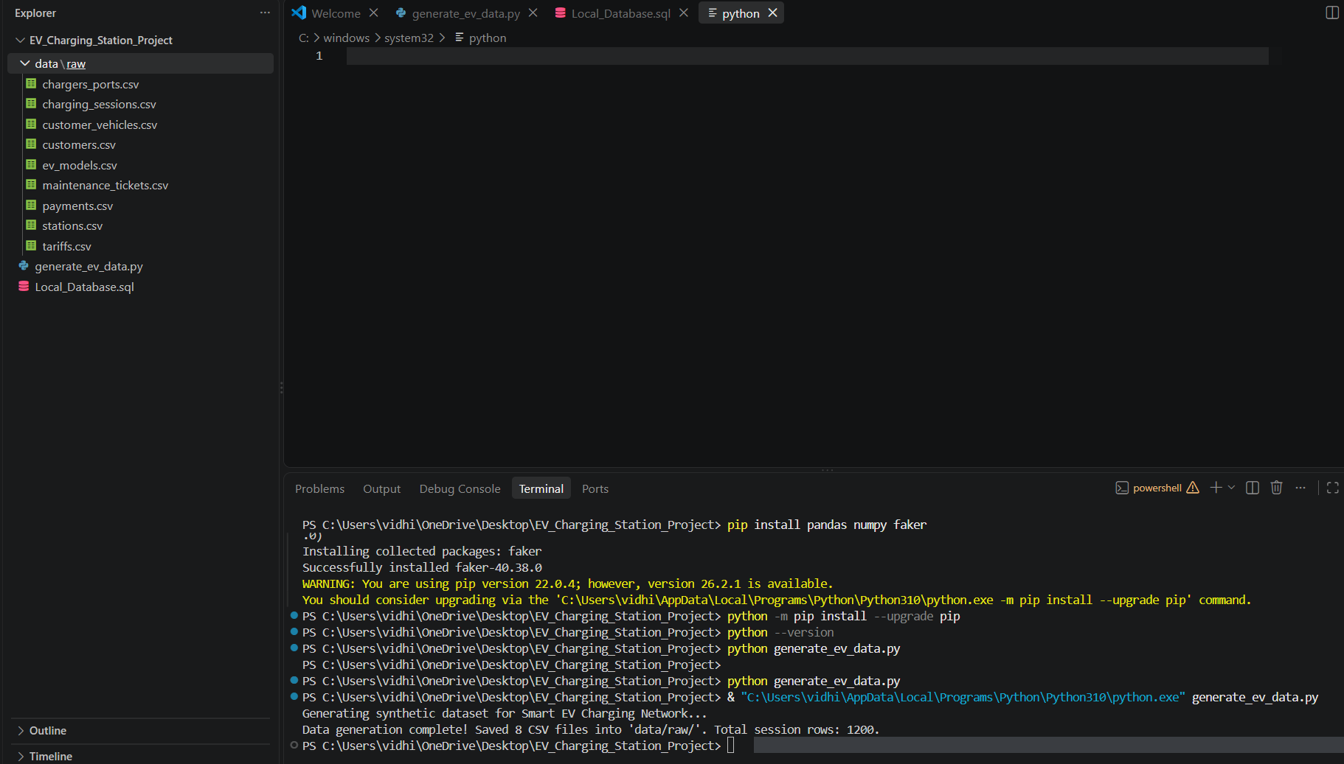

Local_Queries_Success.png
- The Query Tool in pgAdmin displaying a successful execution result grid for one of the key analytical queries.

Query:1
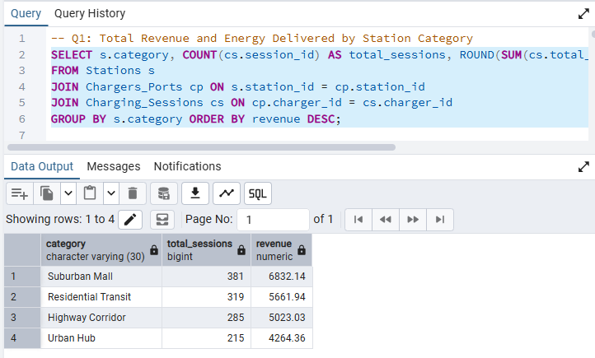

Query:2
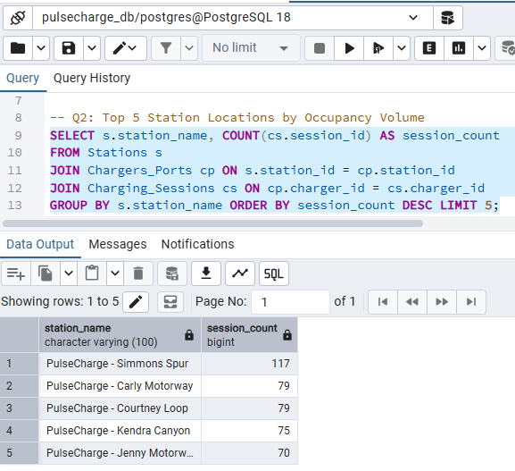

AWS RDS Deployment
1.Provision RDS PostgreSQL or RDS SQL Server (db.t3.micro free-tier eligible)
2.Set Security Group: restrict port (e.g., 5432 for Postgres) to My IP (YOUR_LOCAL_IP/32)
3.Run AWS_Deployment.sql script via pgAdmin/SSMS connected to the RDS endpoint.
VPC, Subnets, Availability Zones are created.

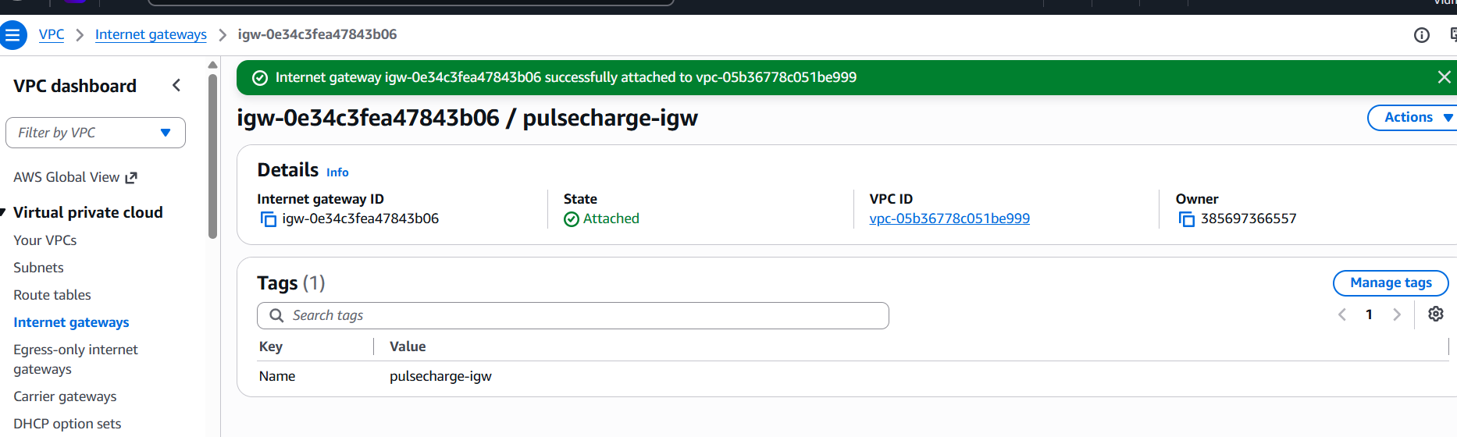

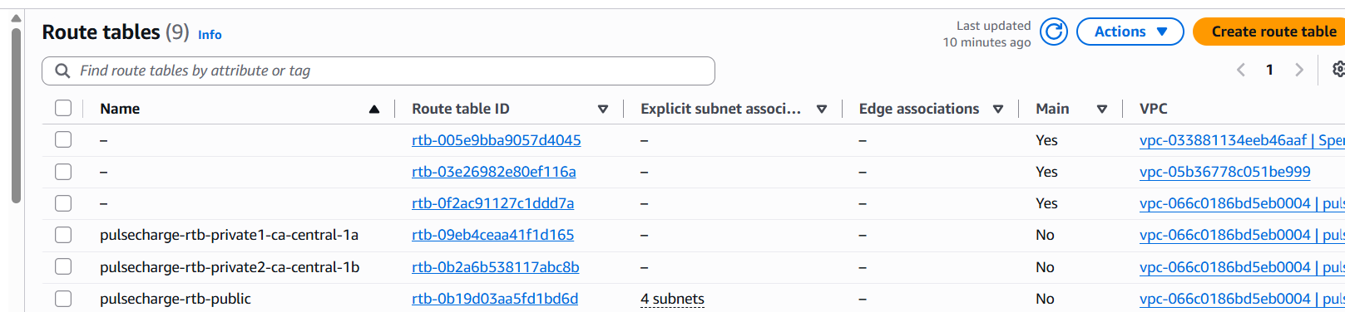

On AWS RDS, database “ pulsecharge-rds-db” is created.

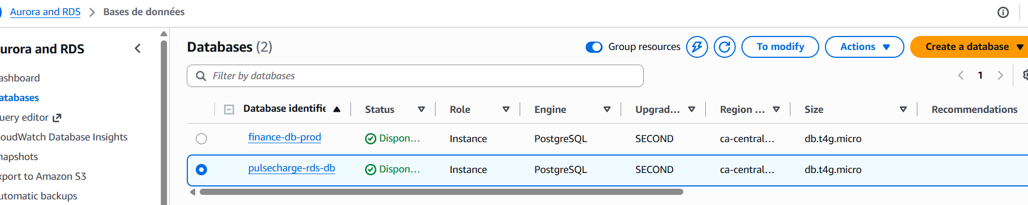

Phase 6: Cloud Data Pipeline (S3 + Glue + Athena)
1. S3 Bucket: Setup structure:
• s3://pulsecharge-analytics-data/raw/ (Original CSV exports)
• s3://pulsecharge-analytics-data/cleaned/ (Post-ETL / Normalized CSVs)
• s3://pulsecharge-analytics-data/athena-results/
2. AWS Glue Crawlers: Run Glue Crawler targeting s3://.../cleaned/ to populate the Glue Data Catalog database schema.

S3 Datalake: pulsecharge-data-lake-102026
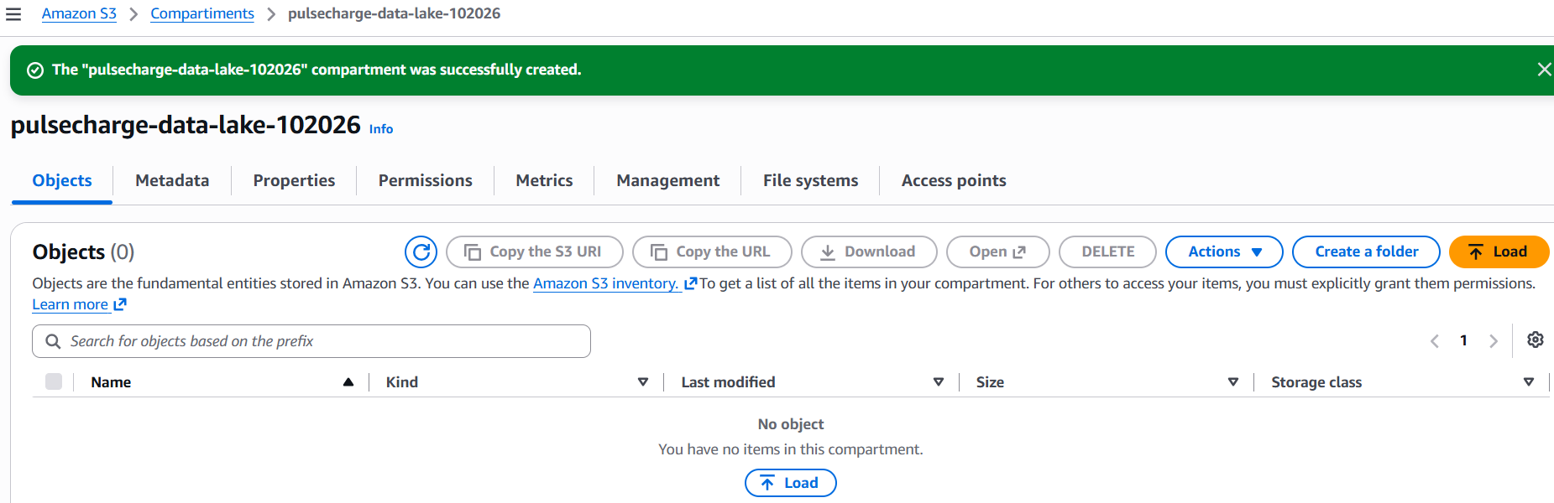

Created folder raw-data/
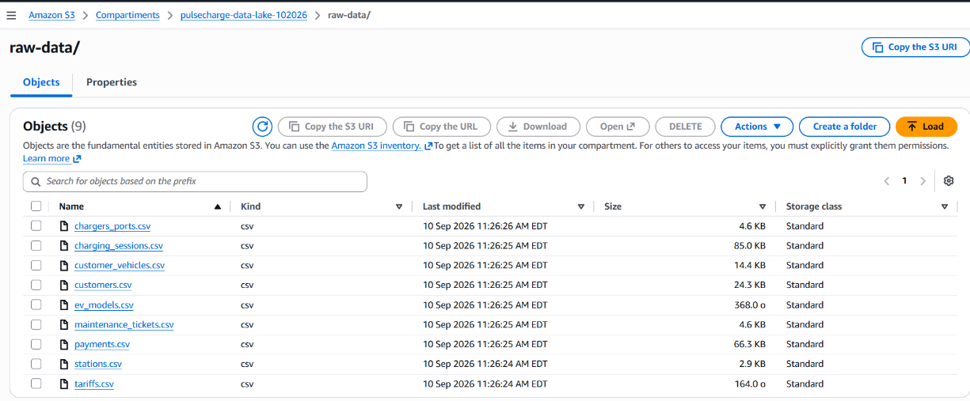

Created IAM Role: PulseChargeGlueRole

Step 1: Create a Glue Database
In the AWS Console, type AWS Glue in the top search bar.
In the left navigation menu under Data Catalog, click Databases.
Click Add database: Name: pulsecharge_catalog_db
Click Create database.

Database Catalog
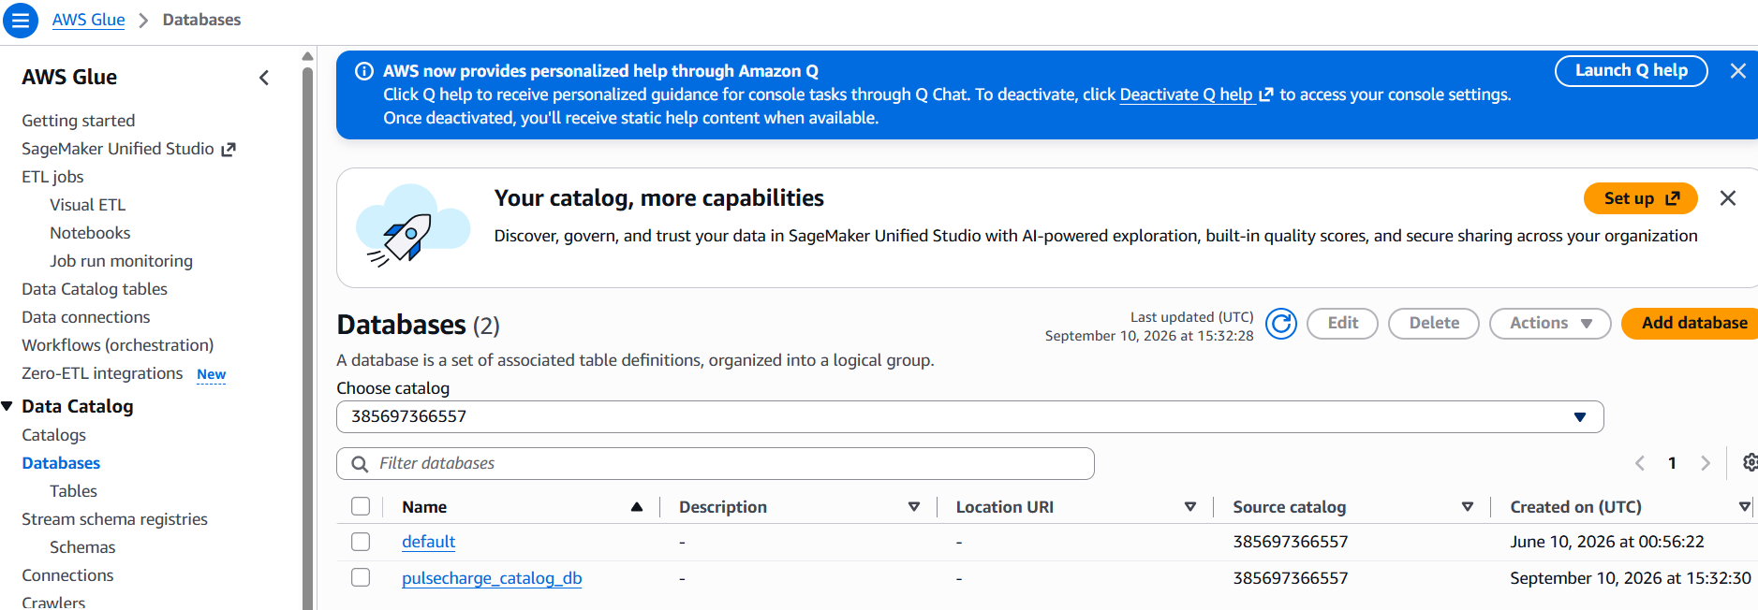

Chose S3 as data sources

Step 2: Choose data sources and classifiers
Click Add a data source.
Data source: Select S3.
Location of S3 data: Select “In this account”.
S3 path: Click Browse S3 and select your raw-data/ folder inside pulsecharge-data-lake-102026 (or type s3://pulsecharge-data-lake-102026/raw-data/).
Click Add an S3 data source.
Click Next.
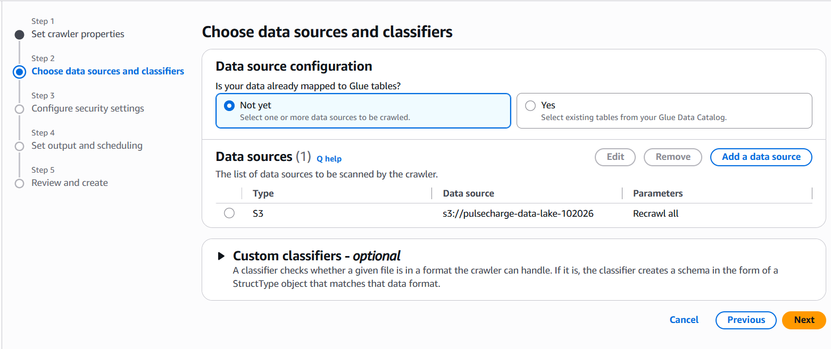

Choose IAM GlueRole

Step 3: Configure security settings
Existing IAM role: Select PulseChargeGlueRole.
Click Next.

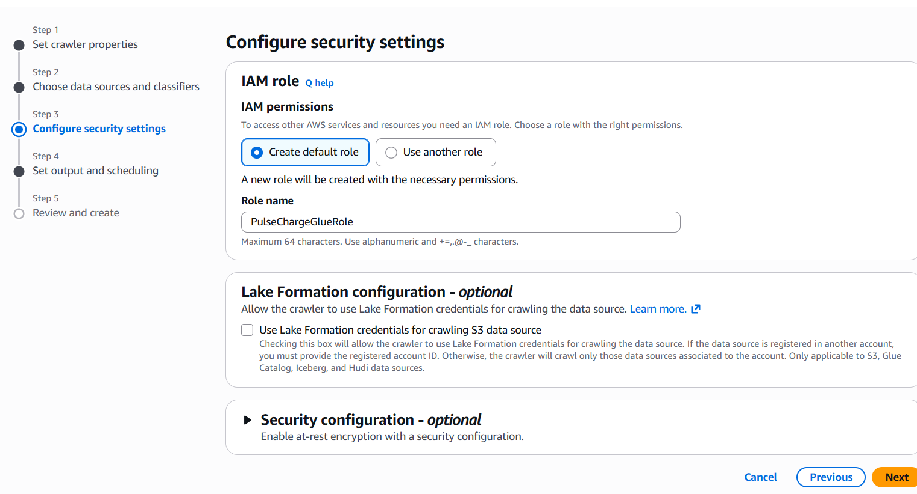

Step 4: Set output and scheduling
Target database: Select pulsecharge_catalog_db (created in Step 1).
Frequency: Keep as “On demand”.
Click Next.
Review the configuration and click Create crawler.

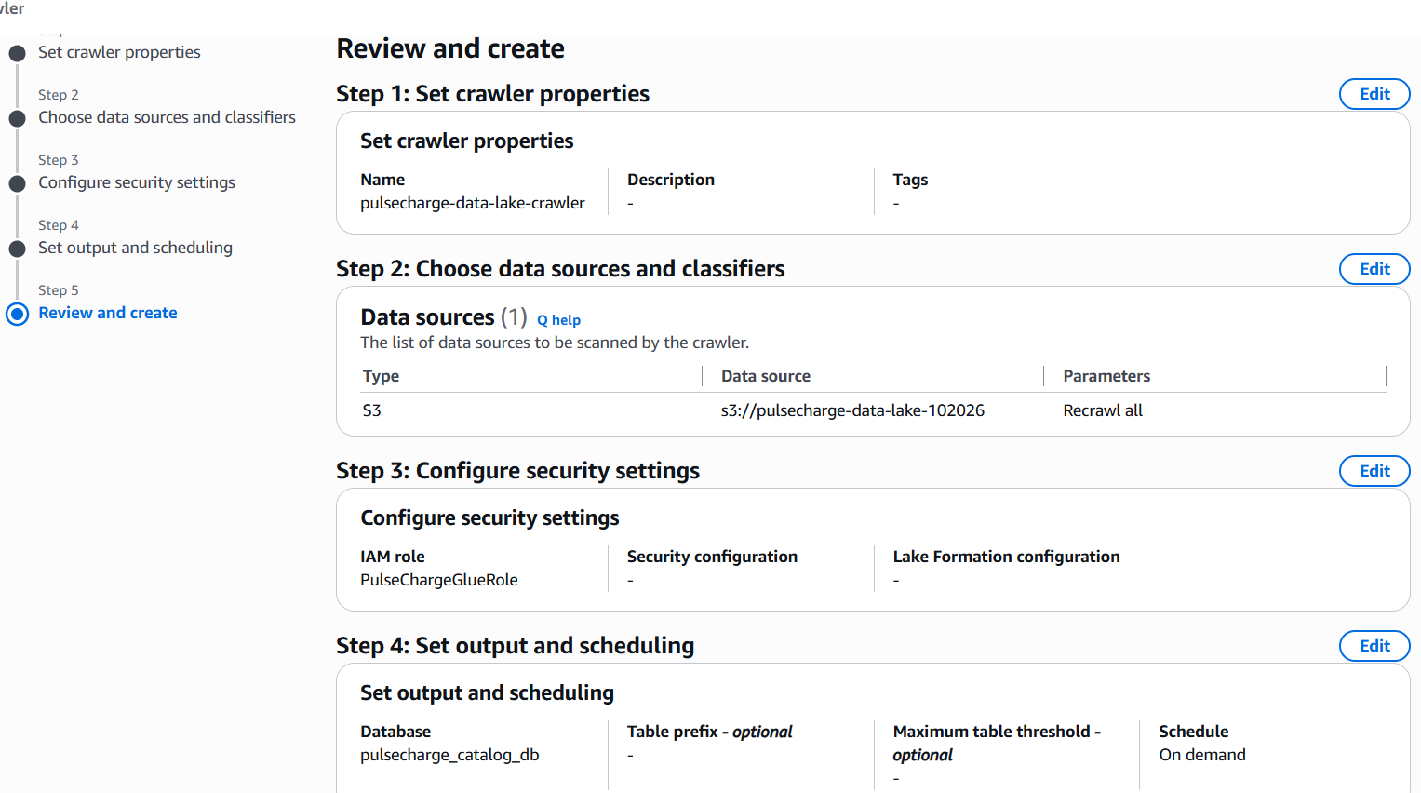
pulsecharge-data-lake-crawler
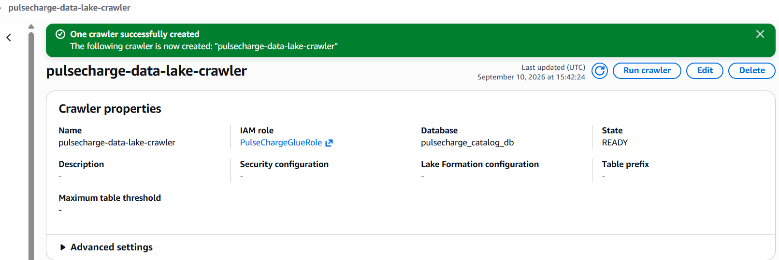
Now that crawler is created, let's run it to discover the schema of your operational CSVs and create tables in your Glue Data Catalog.
- Step 1: Run the Crawler in the AWS Glue Console, select Crawlers from the left navigation pane under Data Catalog. Check the box next to pulsecharge-data-lake-crawler. Click “Run” button at the top right.
- Step 2: Monitor Crawler Status. Watch the Status column for pulsecharge-data-lake-crawler. It will transition through:
Running Glue is scanning your S3 bucket folders.
Stopping Glue is writing the discovered schemas to your Catalog.
Ready The scan is complete.
The entire process usually takes about 1 to 2 minutes
- Step 3: Verify Discovered Tables
- In the left navigation menu under Data Catalog, click Tables.
- Change the Database filter dropdown to pulsecharge_catalog_db.
We can see separate tables listed for each of your subfolders (e.g., sessions, stations, users).
Click on any table name to open its details and verify that AWS Glue correctly detected column names and data types (such as string, bigint, or double).

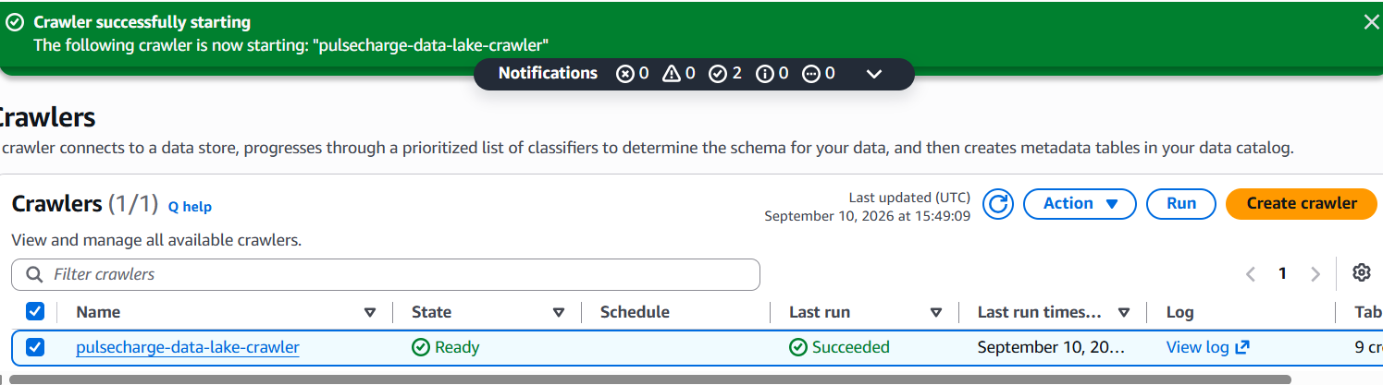

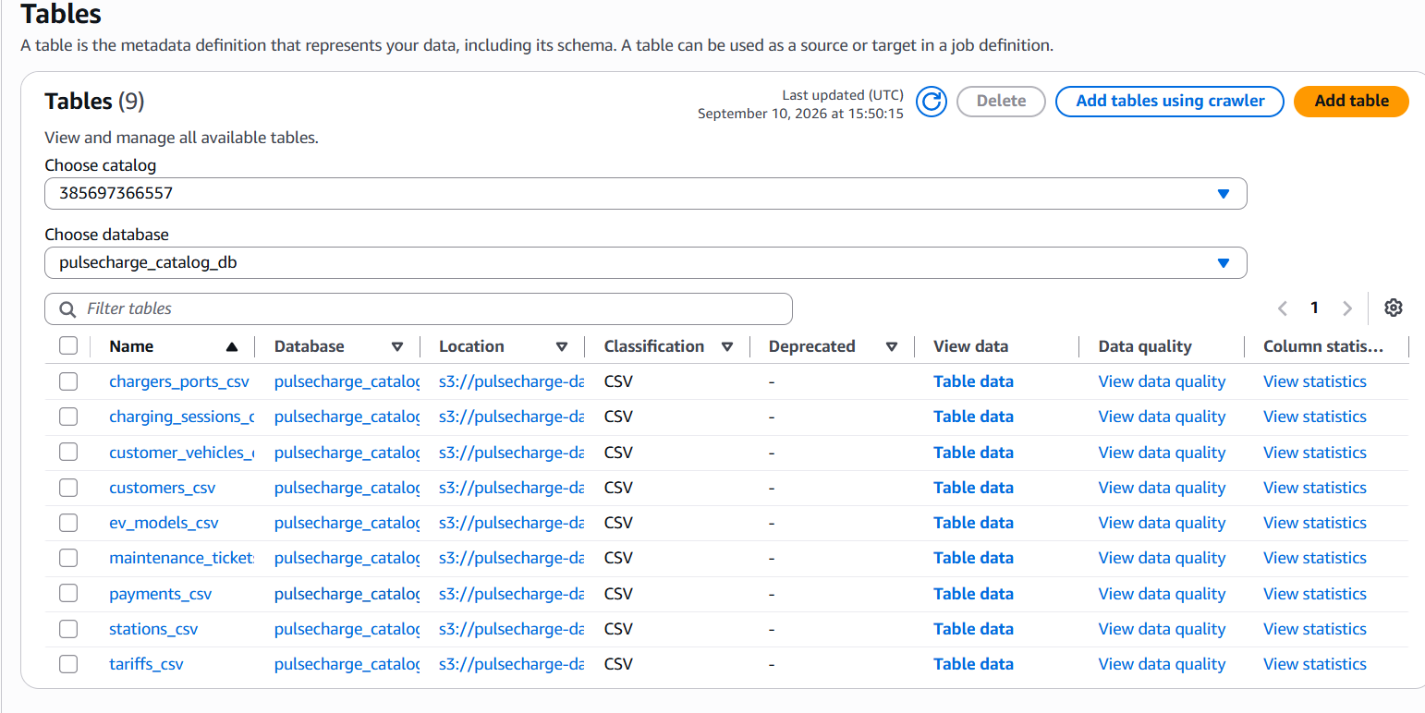
Click on any table name to open its details and verify that AWS Glue correctly detected column names and data types (such as string, bigint, or double).

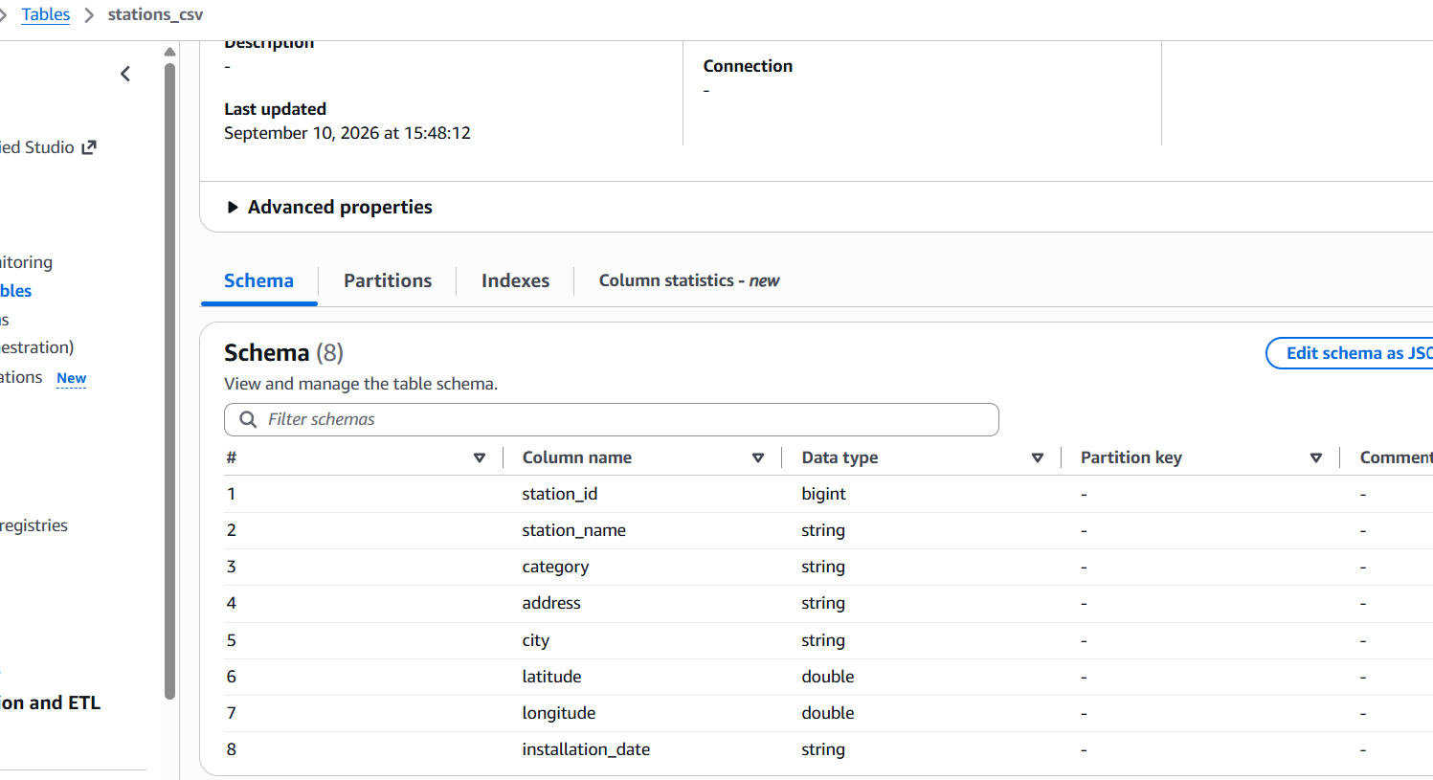

Amazon Athena

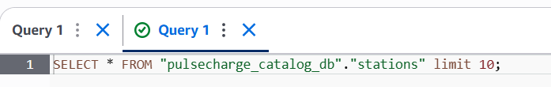

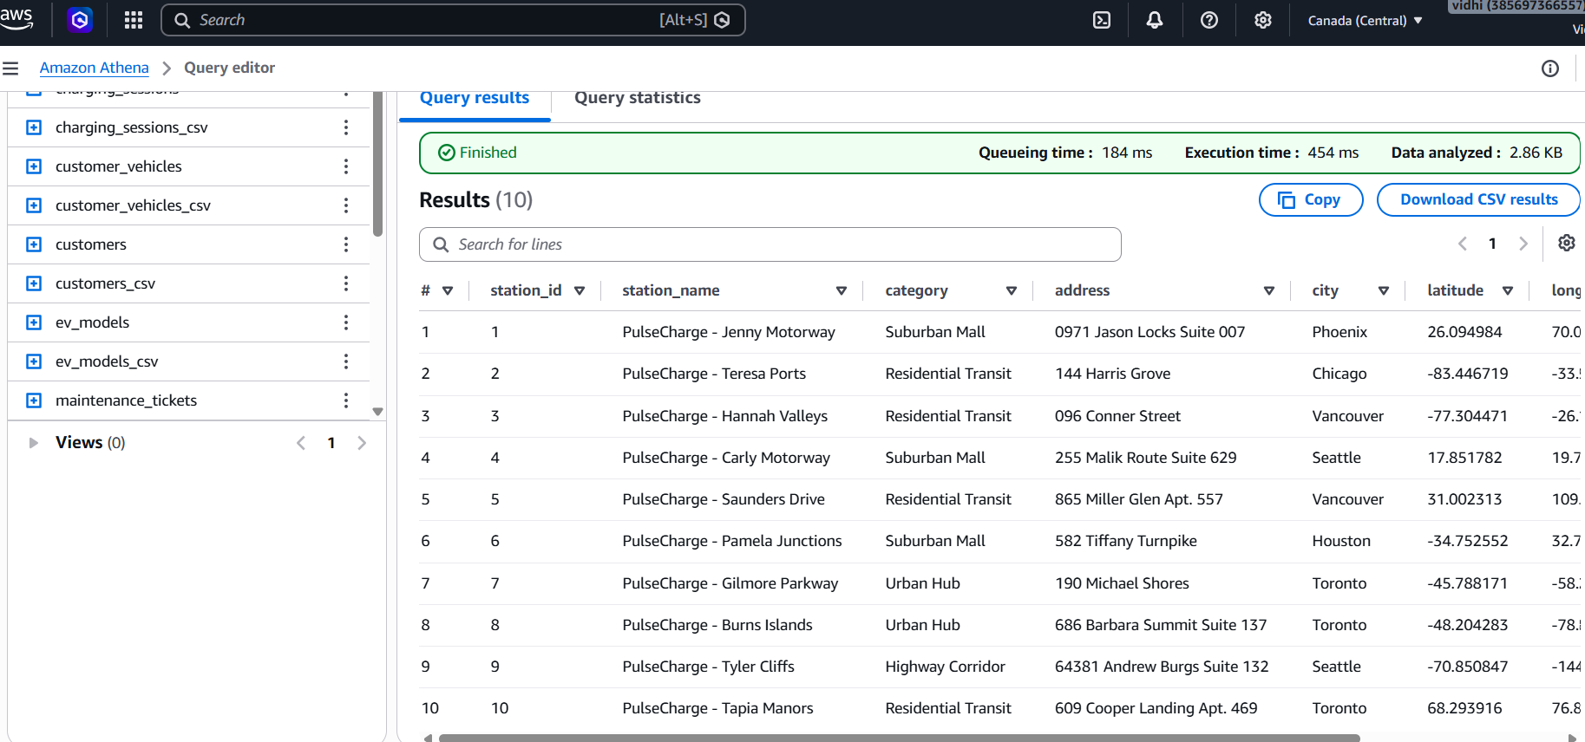

With storage and ad-hoc querying in place, we can now move to

Data Transformation & Pipeline Automation (Glue ETL).
In this phase, we will set up a Glue Studio job to transform your raw CSVs into compressed, columnar Parquet format and save them in a transformed-data/ S3 folder for production analytics.

Step-by-Step Setup: CSV to Parquet Pipeline

1.Create a New Visual ETL Job:
In the AWS Glue Console, go to ETL jobs in the left navigation menu.
Select Visual ETL.
Under Create job, leave the default visual options and click Create.
Click the Job details tab at the top.
Set Name to: pulsecharge-csv-to-parquet-job.
Set IAM Role to: PulseChargeGlueRole.
Scroll to Advanced properties, find Maximum concurrency, and set it to 3.

2.Configure the S3 Source Node (Raw CSV):
Click the Visual tab at the top left to return to the canvas.
Click the + (Add node) button or select Source Amazon S3.
Click the new Amazon S3 Source node on the canvas.
In the right panel under Data source properties - S3
S3 source type: Select S3 location.
S3 URL: Enter s3://pulsecharge-data-lake-102026/raw-data/charging_sessions/
Data format: Select CSV.
Delimiter: Select Comma (,).
Check the box for First line contains column headers.

3.Configure the S3 Target Node (Transformed Parquet):
Click the + (Add node) button or select Target Amazon S3.
Click the new Amazon S3 Target node on the canvas.
In the right panel under Data target properties - S3:
Node parents: Select your Amazon S3 Source node.
Format: Select Parquet.
Compression Type: Select Snappy.
S3 Target Location: Enter s3://pulsecharge-data-lake-102026/transformed-data/charging_sessions/
Expand Advanced options and set Target folder action to Delete existing keys in the target directory.

4.Save and Execute:
Click the blue Save button in the upper-right corner.
Click Run.
How to Verify
Click the Runs tab at the top of the canvas.
Wait 1–2 minutes for the status to show Succeeded.
Navigate to s3://pulsecharge-data-lake-102026/transformed-data/charging_sessions/ in the S3 console to see your generated .parquet files.
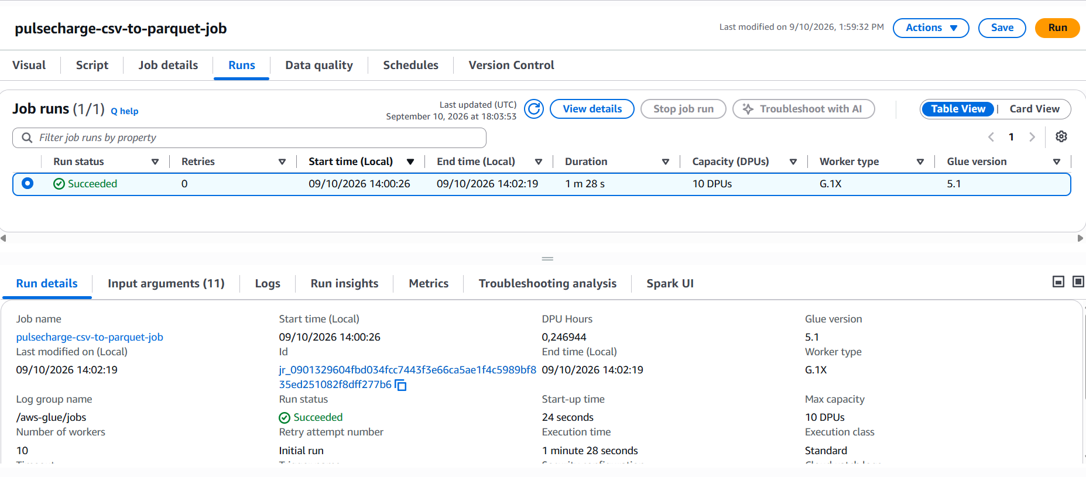
Now that the Glue ETL job has succeeded, our raw CSV data has been converted into compressed Parquet files sitting in your transformed-data/ folder.
The final phase is to run a Glue Crawler so the AWS Glue Data Catalog auto-discovers your Parquet schema, allowing you to run fast SQL queries in Amazon Athena.
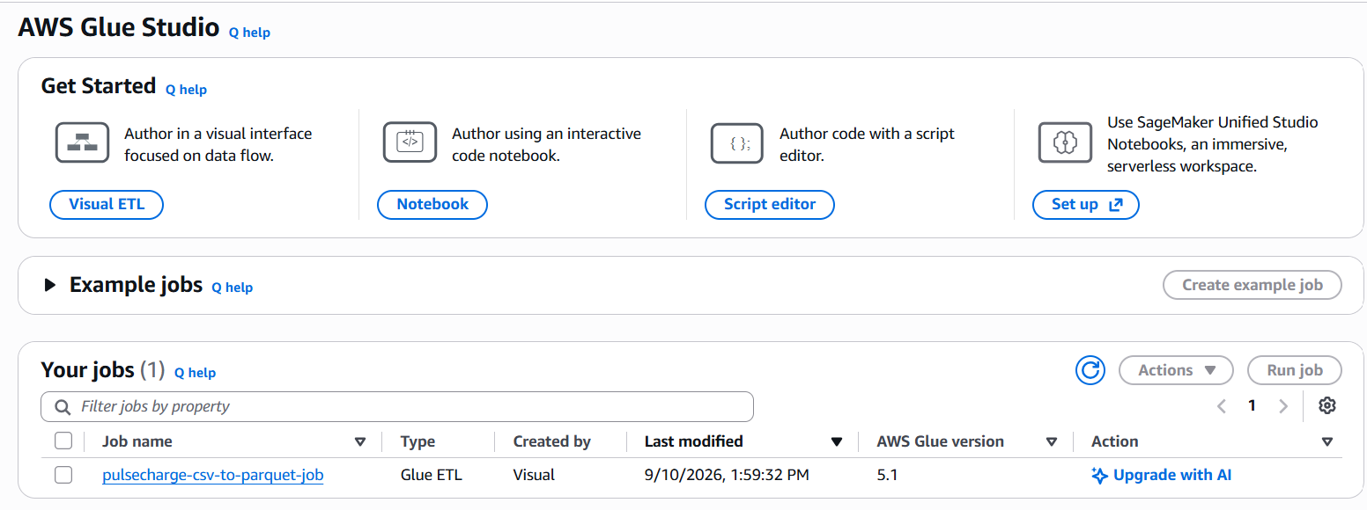
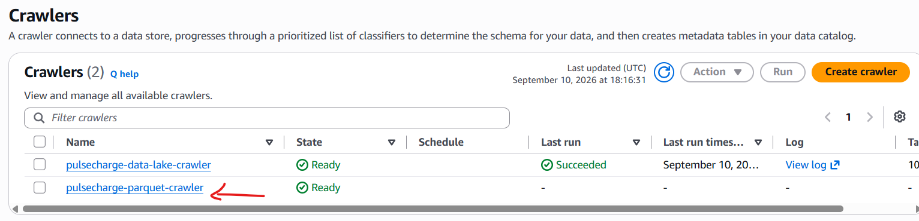

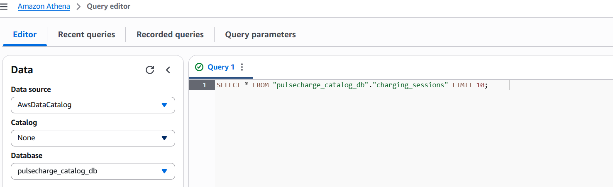
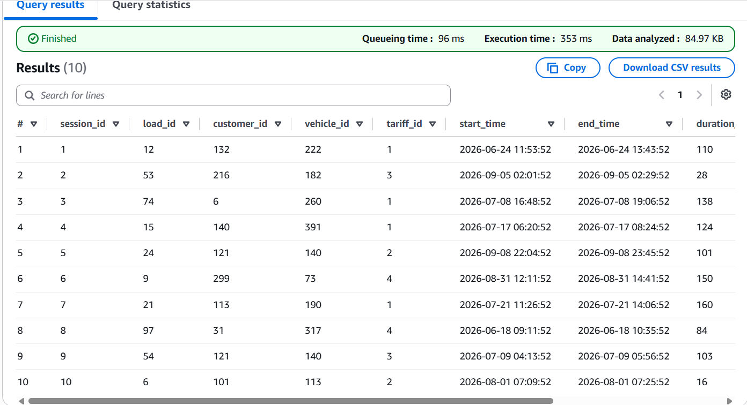
pipeline is now complete. Converting raw CSV files to Snappy-compressed Parquet reduced file storage size, improved Amazon Athena query speeds, and lowered data scan costs per query

Phase 7: Data Mining & Analytics

Queries on Athena

Query 1: Overall Network Performance (Aggregation)
- Analysis Technique: Aggregation & Statistical Profiling
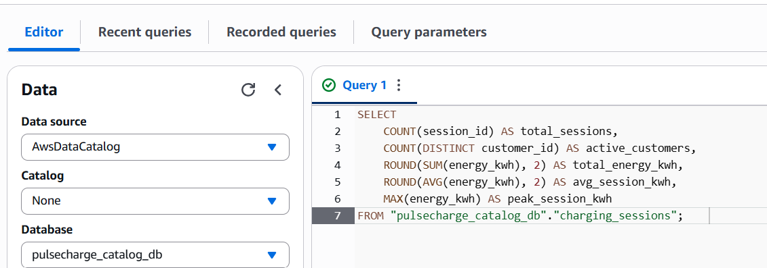
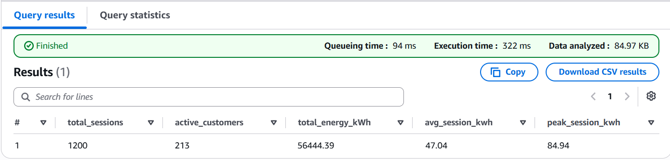
Plain-Language Method Explanation: This query aggregates the entire historical dataset using built-in SQL statistical functions (COUNT, SUM, AVG, MAX). It counts the total number of charging sessions, identifies unique customers, sums total energy delivered, and determines average and maximum energy consumed per visit.
Business Meaning & Value: Establishes operational baseline KPIs for the PulseCharge network. It allows leadership to evaluate network load capacity and determine average energy consumption per session to forecast utility grid expenses.

Query 2: High-Volume Customer Segmentation (Thresholding Analysis)
- Analysis Technique: Thresholding & Heavy-User Filtering
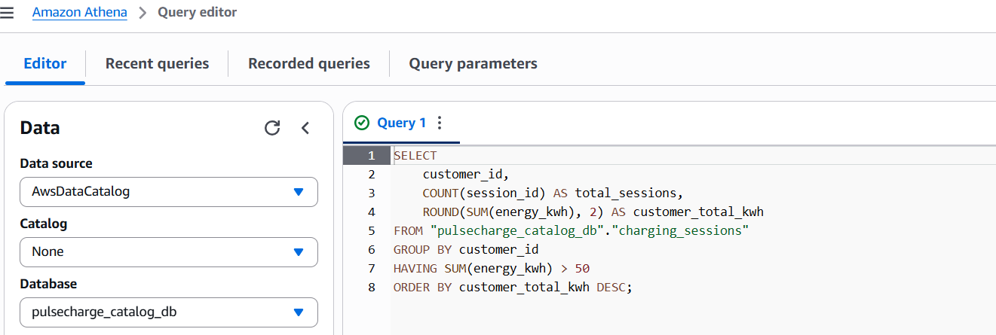
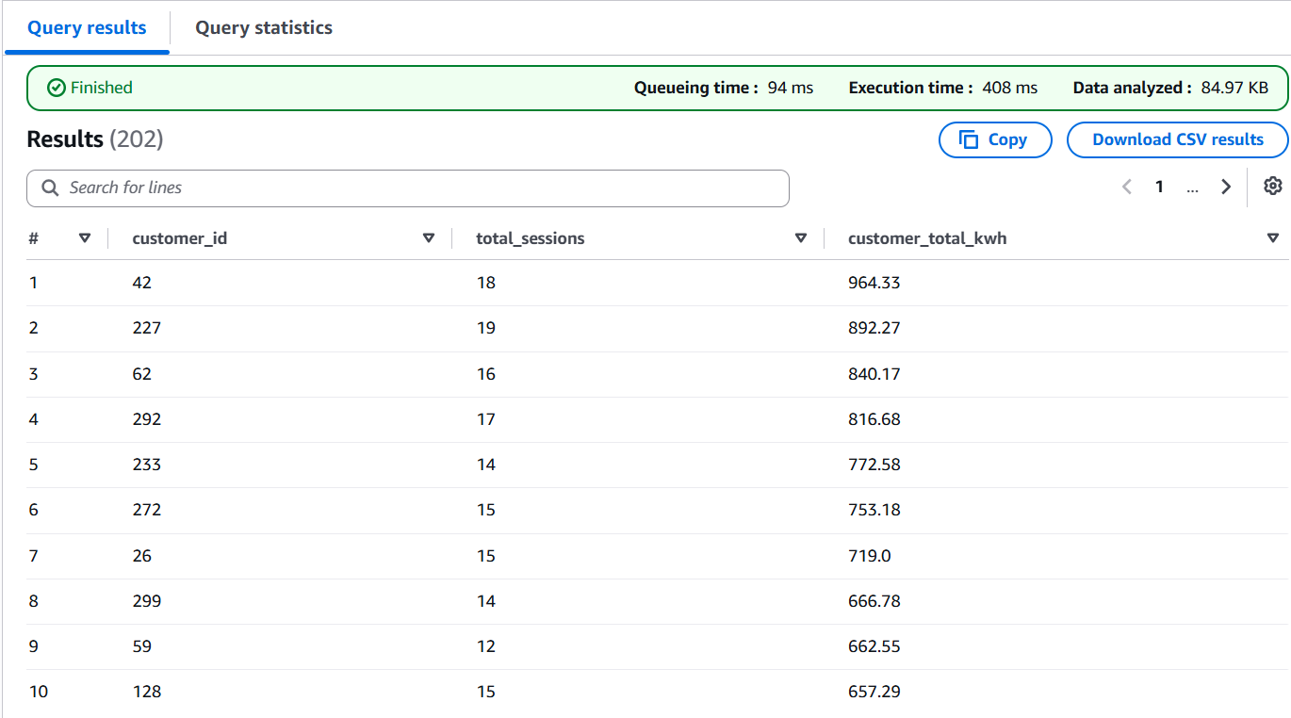
Plain-Language Method Explanation: This query groups all charging logs by individual customer IDs and uses the HAVING clause to filter out low-usage accounts. It isolates only high-volume customers whose total lifetime consumption exceeds 50 kWh.

Business Meaning & Value: Identifies high-value EV drivers and commercial fleet operators generating the highest usage on the network. Marketing teams can target these accounts with loyalty rewards or corporate subscription packages to maximize customer retention.

Query 3: Session Energy Categorization (Classification Logic)SQL
- Analysis Technique: Dynamic Classification & Binning
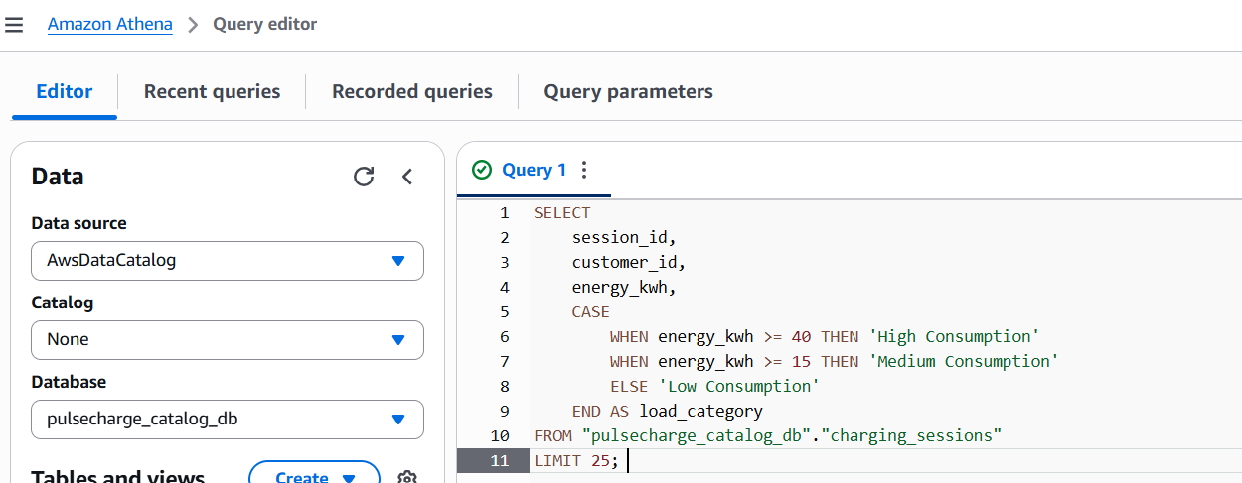
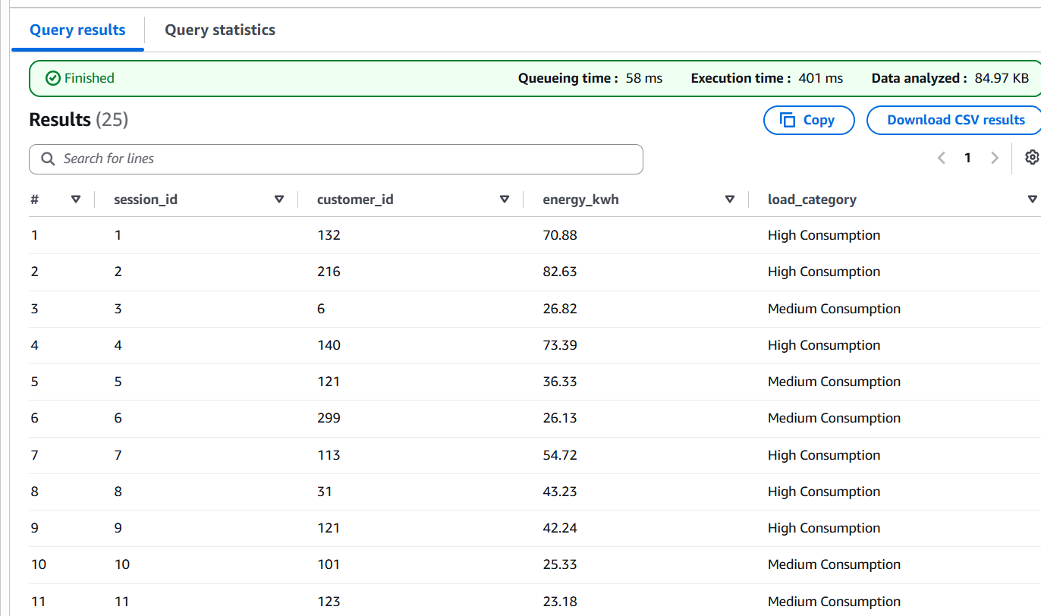
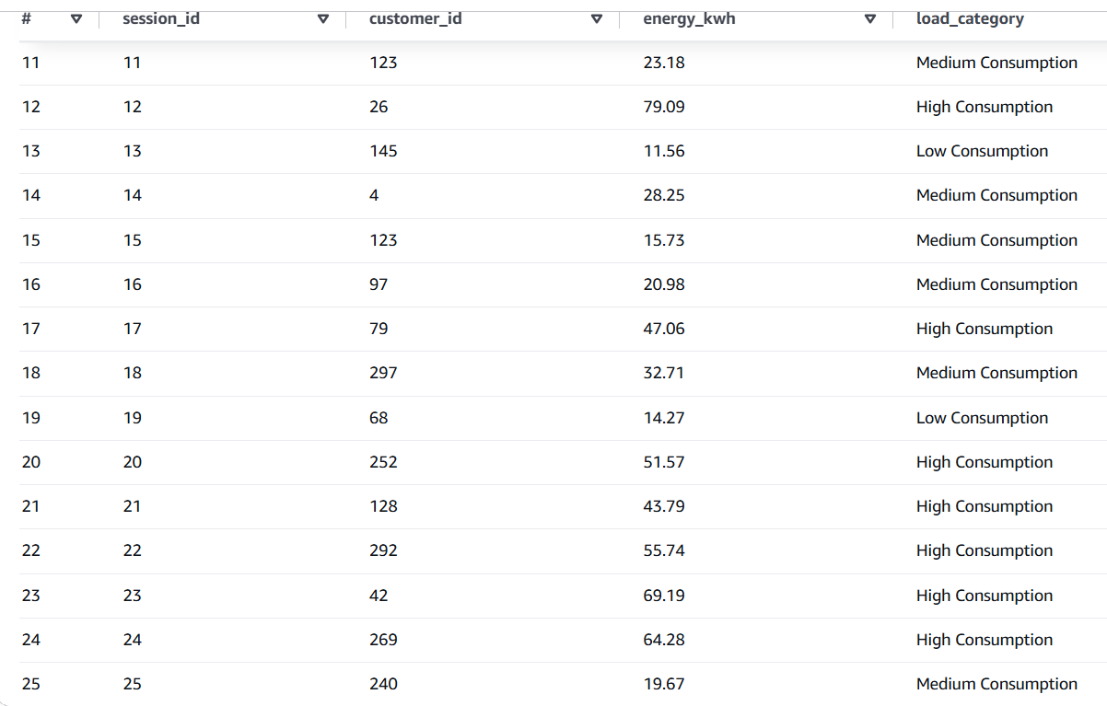
Plain-Language Method Explanation: This query uses conditional logic (CASE WHEN) to assign each charging session to a load category ("High Consumption", "Medium Consumption", or "Low Consumption") based on pre-defined energy consumption thresholds.
Business Meaning & Value: Categorizes raw session data into actionable operational tiers. Grid operations teams can monitor the ratio of "High Consumption" sessions to manage electrical transformer loads and mitigate power surge risks during peak operational hours.

Query 4: Customer Usage Tier Ranking
- Analysis Technique: Tiered Segmentation via Window Functions

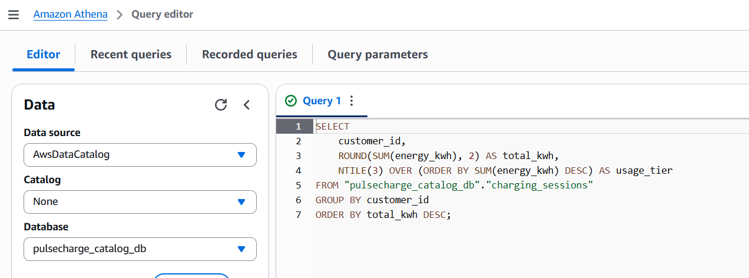
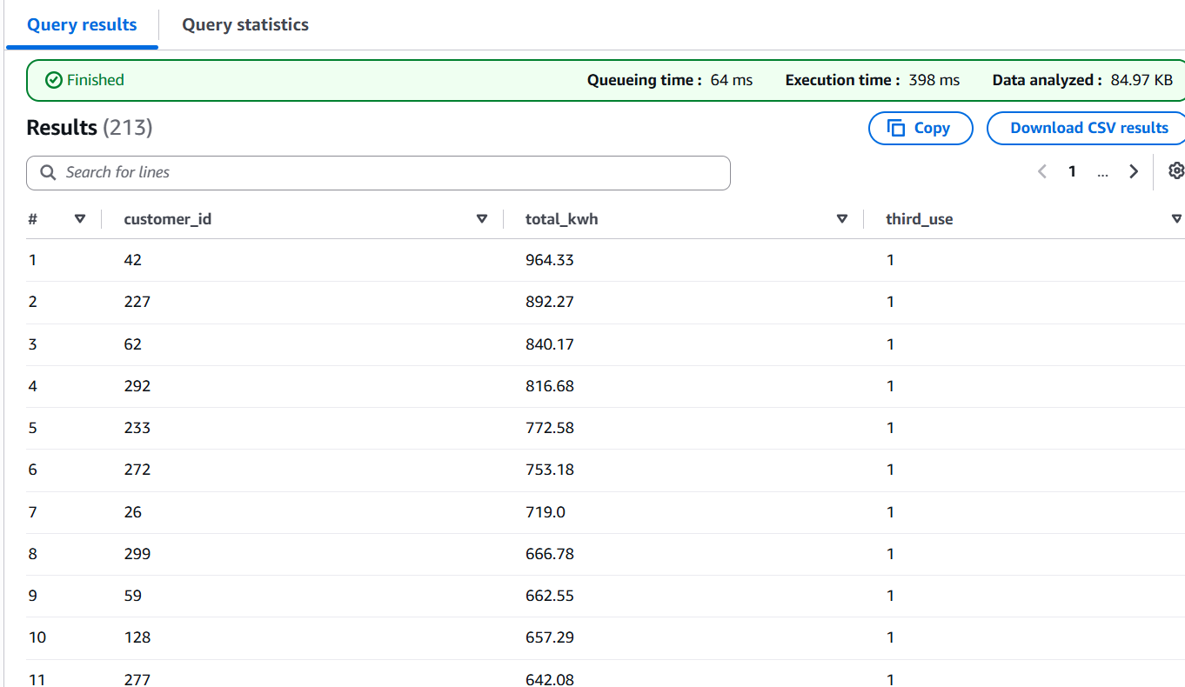
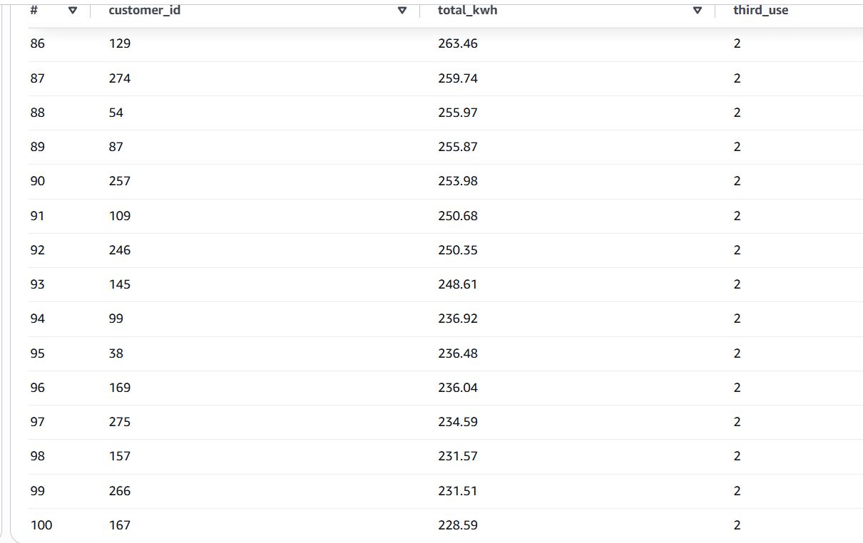

Plain-Language Method Explanation: This query calculates total energy consumed per customer and applies the NTILE(3) window function to rank and divide the entire customer base into three equal statistical tiers (Tier 1 = Top 33% users, Tier 2 = Middle 33%, Tier 3 = Bottom 33%).

Business Meaning & Value: Provides an objective breakdown of customer behavior without relying on arbitrary cutoff values. The business can design tiered pricing strategies—offering peak discounts to Tier 3 users to encourage usage, while offering Tier 1 users premium access rights
We successfully built an end-to-end cloud pipeline: from raw CSV storage in Amazon S3, through serverless transformation using AWS Glue Visual ETL into Snappy-compressed Parquet, down to automated cataloging and optimized querying in Amazon Athena.

Phase 8: Dashboard & Final Submission Checklist
Dashboard Requirements (Power BI / QuickSight / Excel)
• 5 Visuals:
1. Line Chart: Hourly Energy Demand (kWh) by Station Cluster.
2. Bar Chart: Revenue by Charger Type (DC Fast vs Level 2).
3. Donut Chart: Charger Port Status breakdown (Available, Occupied, Offline).
4. Scatter Plot: K-Means Station Clusters (Session Count vs. Revenue).
5. Table: Top 10 High-Downtime Stations requiring maintenance.
2 Interactive Slicers: Date Range Selector, Region/Station Cluster Filter

Conclusion:

PulseCharge Data Lake & Analytics Pipeline
- The PulseCharge project successfully established a scalable, cost-effective, and automated end-to-end data engineering pipeline within the AWS cloud environment (ca-central-1).
- By implementing a modern medallion-style architecture, the project transformed raw, unstructured CSV datasets into optimized columnar storage formats, unlocking high-performance querying and actionable business insights.

